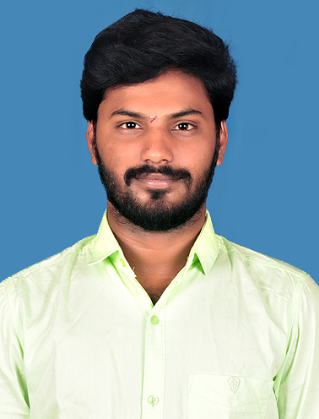

WEB DEVELOPER

GOWTHAM P

Interested in the role of a Software Engineer where I can contribute my analytical skills and knowledge acquired by pursuing my degree in Software Engineering. Looking for a dynamic and progressive company where my skills are utilized in the maximum way posible.



[git@github.com:GowthamBoy1213/THE-ROYAL-ASSOCIATES.git](mailto:git@github.com:GowthamBoy1213/THE-ROYAL-ASSOCIATES.git)

***Muthiah Polytechnic College, Chidambaram*** |72% 2020

D.ECE – Annamalai University

***Besant Technologies, Velachery*** | 2023

Java Full Stack Development

HSC – State Board

***SKV Higher Secondary school, Kurinjipadi*** |68% 2017

SSLC - State Board

***SKV Higher Secondary school, Kurinjipadi*** |60% 2015

INTERESTS

* Tennis
* Swimming
* Bike Riding
* Video Editing
* Photoshop
* HTML 5
* CSS 3
* JavaScript
* Bootstrap
* React JS
* Java
* MySQL

*THE ROYAL ASSOCIATES WEBSITE (03/2023 - Present)*

www.theroyalassociates.com

PERSONAL PROJECTS

PROFESSIONAL EXPERIENCE

Magna Automotive India pvt ltd.

***QUALITY LCS (Inspector) - LETAR*** | 2020 - 2022

* Quality Assurance: Ensure the accuracy and completeness of processed transactions and claims, minimizing errors and discrepancies.
* Regularly updated social media accounts.

*PLACE*: Chennai

*Date*:

(Gowtham.p)

I hereby, solemnly declare that the above furnished details are true to my conscience & belief.

* Diagnoses and troubleshoots products for repair.
* Completes routine functionality and quality testing on all products.

DECLARATION

+91 9003709570

Gowthamhero2000@gmail.com

North Street, Rajakuppam, Arangamangalam (Post), Kurinjipadi (TK), Cuddalore (DT).

©AZURIUS - My-resume-templates.com

SKILLS

CONTACT

EDUCATION

***Testing* Operator** | 2022 - 2023

NOKIA

©AZURIUS - Modelos-de-curriculum.com